User Manul
Game Menu
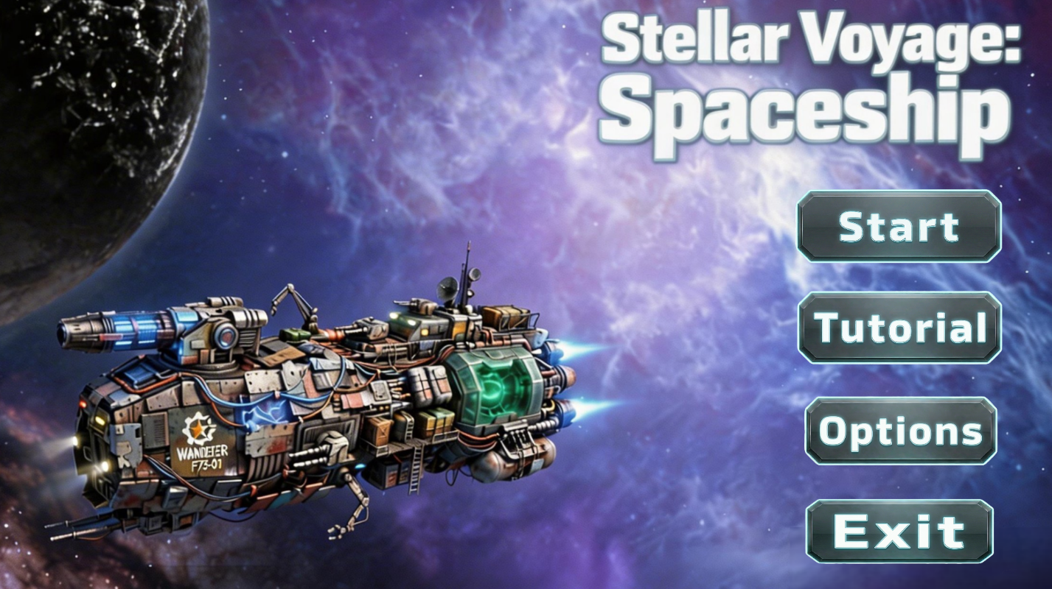
Press “Exit” to escape from the game.
Press “Options” to set the volume of music…
Press “Tutorial” to enter the game

Option Panel（After pressing the “Options”）
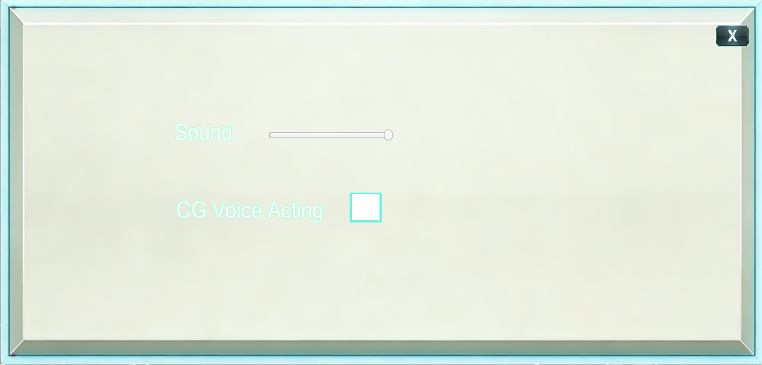
Click the box to open the excellent CG Voice Acting
Click the “X” button the exit from the options panel
Drag the slider to set the volume of sound (left to right, min to max)
CG Playing (After pressing the “Tutorial”)
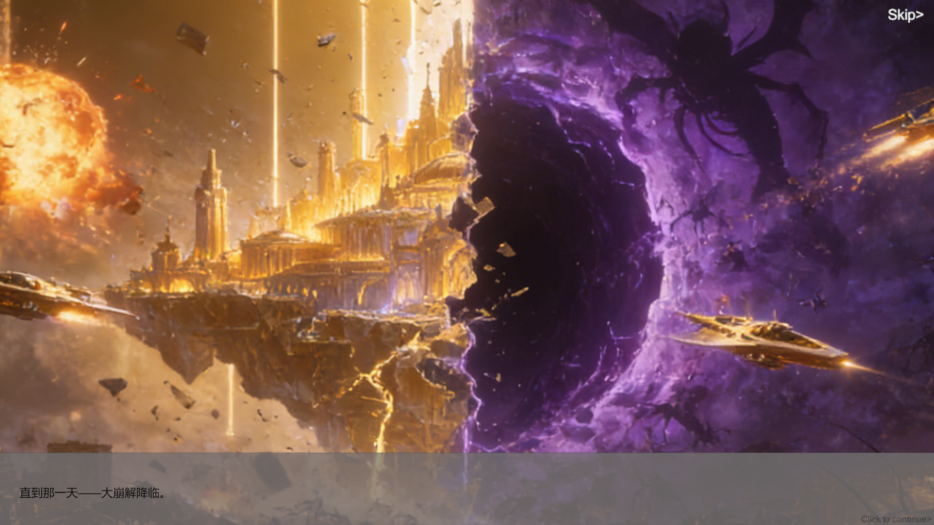
Press “Esc” to stop the CG and moves to options panel (set the volume of sound…)
Click the “Skip>” button to skip watching the CG
Below is the dialog that introduces the story

Tutorial NPC Teaching (After finish watching the CG or Pressing the “Skip”)
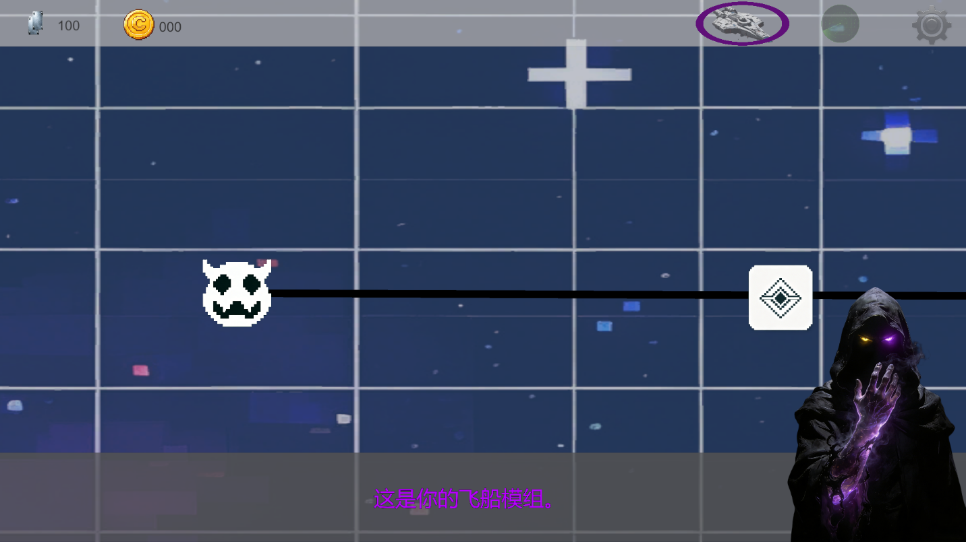
Left click your mouse to continue the teaching dialog
Above is the dialog that teaches the player the function of each icon
The map (After finish the NPC teaching)
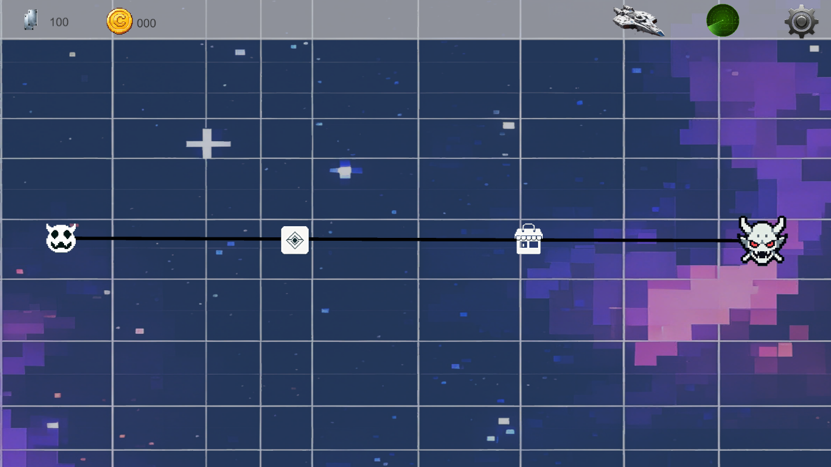
Left click your mouse to select the enabled-enter node, (from left to right are enemy, event, shop, boss nodes respectively)

The node of Fighting Enemy (After select the enemy node)
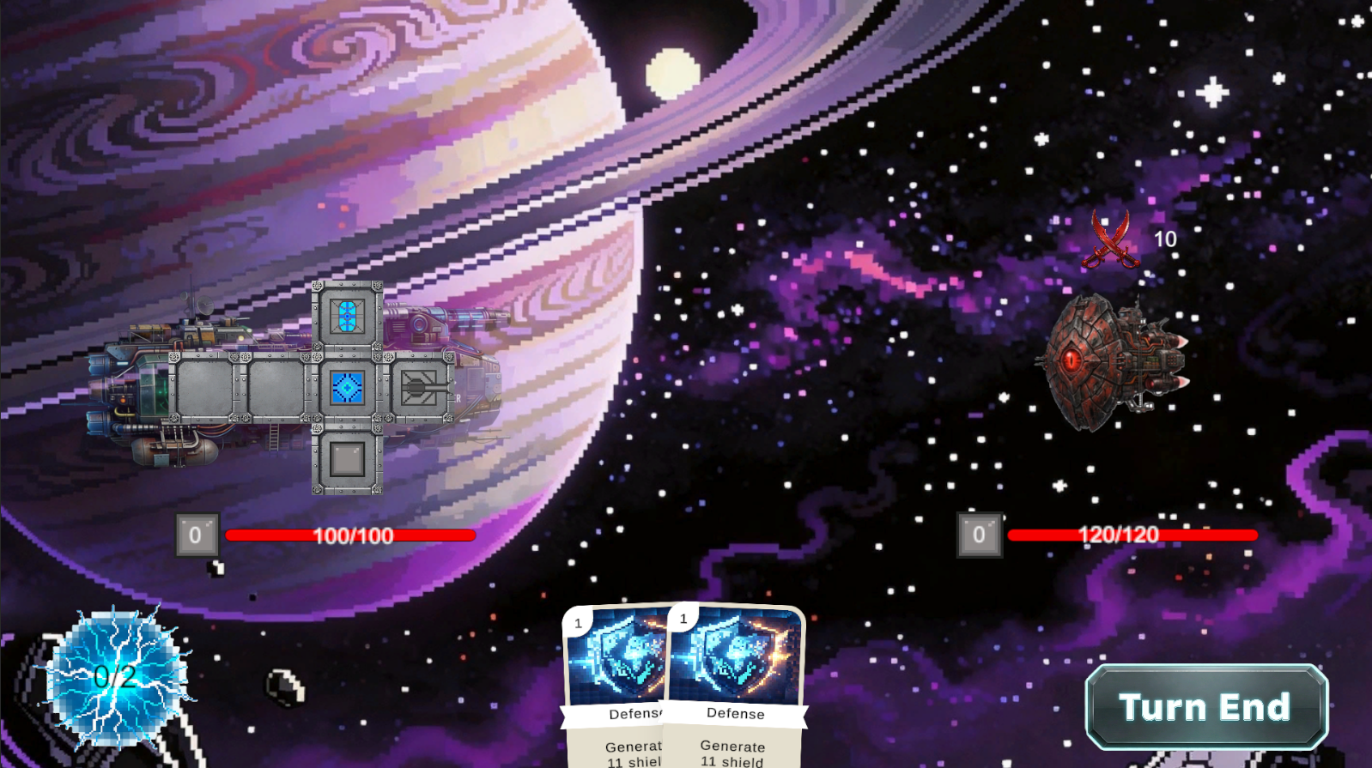
Below is attack or defense tendency of enemy
Left is the enemy that you fight with
Below is the starship of the player that you fight with
1.Right click the module to get card and cost 1 electricity
2.Above are the cards to use
Above is the shield, if being attacked, subtract shield first to 0 then hp
Left hand side is HP
Left click your mouse to change the type of energy that is used.
Dragging the cards to the middle to use (After clicking the modules)
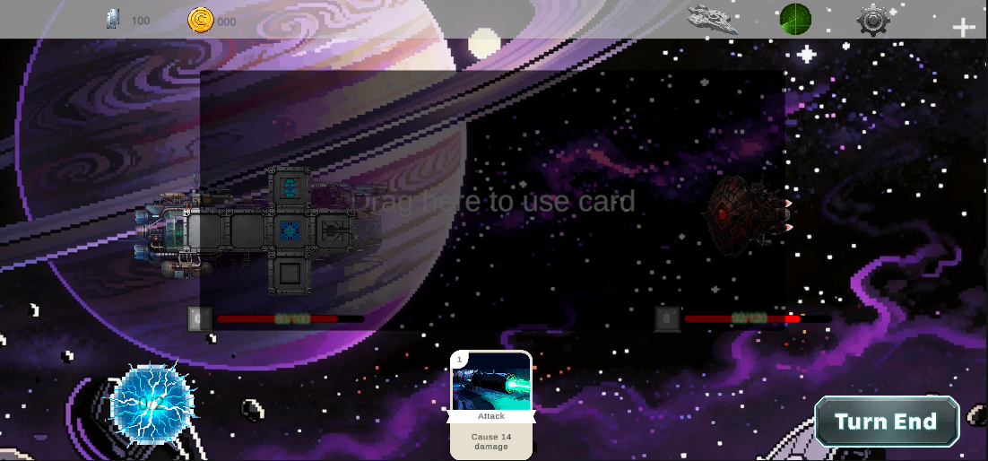
4.Left click the above “Turn End” after spent out all cost
3.Drag the card to the middle to use cards

Attack animation (After Turn End)
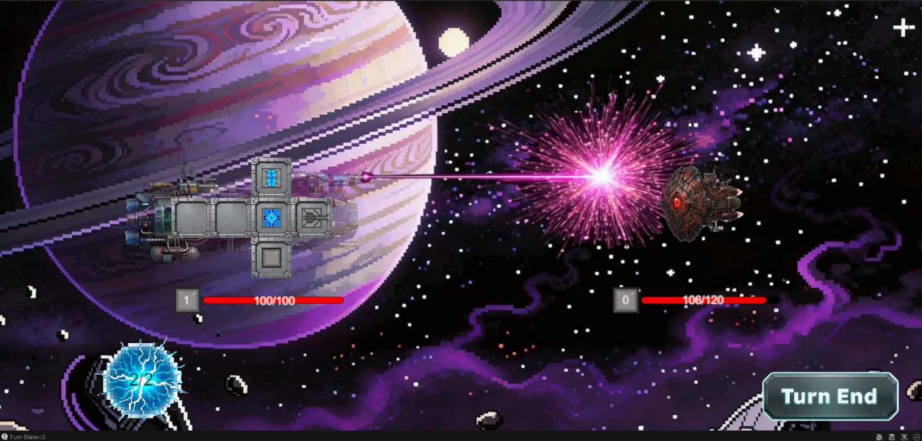

Display the player has won after finish fighting with the enemy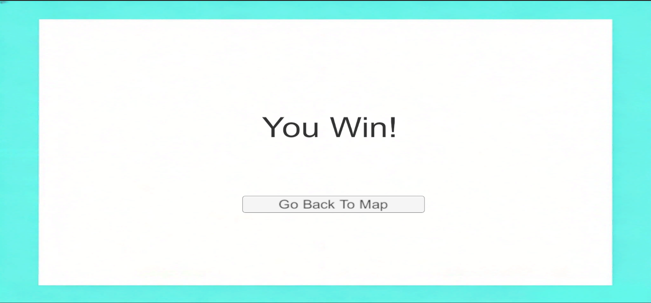
5. Click to go back to the map
Go back to map after finish fighting with the enemy

Go to the next node which is event

Go into the event node after clicking into the event node
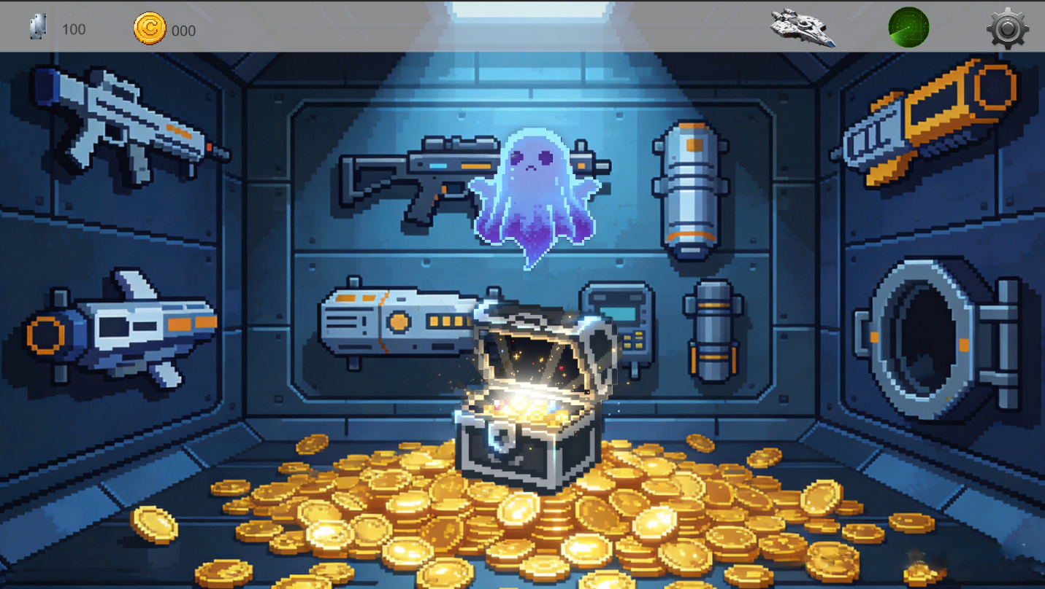
Equipment: Left click to collect
Chest: Left click to open
Go back to the map after finish getting treasure from the event

Go to the next node which is shop

Go into the shop node after clicking into the shop node
Go back to the map after finish getting goods from the shop

Go to the next node which is boss
Go into the boss node after clicking into the boss node
Go back to main title after defending the final boss

